Final Project: Power Supply

Design a power supply circuit using LM 311:
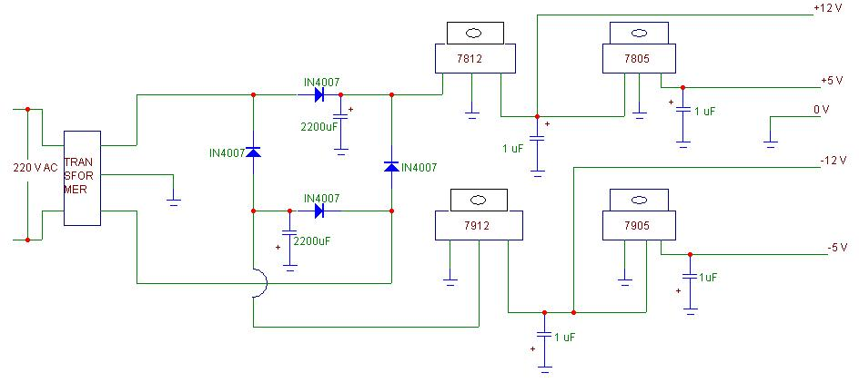Illustration 1: Example

- Input signal : 15 – 30V
- Output signal : 5 – 9V

Schedule

April 30: MultiSim Simulation – Need to turn in the file
May 5: Prototype circuit on breadboard – outputs should be checked by me

