Project: Design a Power Supply circuit
Due: Monday, May 11, 2009
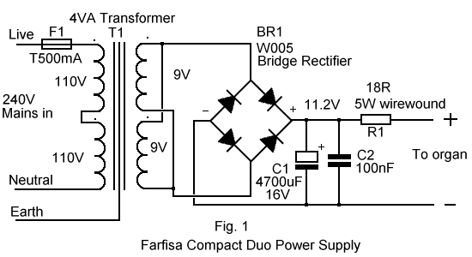
Specifications:
Input: 120V _{AC}
Output: 13V_{DC} or higher
Load regulation: less than 2% or Line regulation: Less than 1%/Δ

File to turn in : your name_power supply.mst

