LMP Island Competition

Requirements & Schedule

Day One

Registration desk with White board and Event Calendar

1 Room for Welcome/Overview

1 Room for each team to complete the Hospitality Project, with all materials and
tables

Day Two
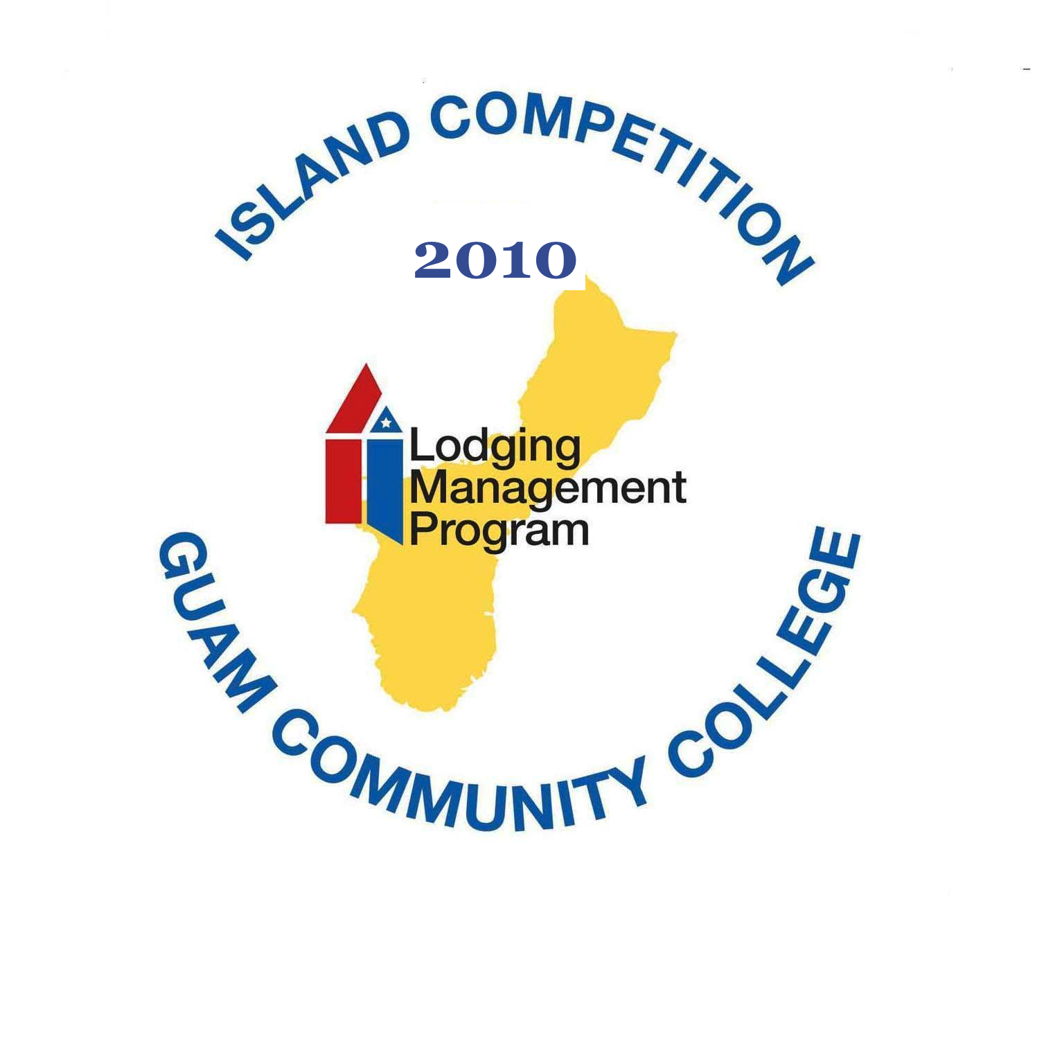
Rooms for competition

Five rooms, one for each team to complete their Night Audit and two case studies. Each team will use the same room to complete their projects and also conduct their presentations.

Main Room for the Knowledge Bowl Competition. With screen, microphones, 4 6” tables, podium and theater style seating for audience.

Green Room is room 301 for students not competing to stay while the other teams are competing

Awards Luncheon
Stage, microphone, screen, 6” table on stage

Set up for Luncheon
LMP Island Competition
Requirements & Schedule

Day One

9:00 – 9:10 a.m. Registration & Check-in
9:15 – 9:45 a.m. Welcoming Remarks, Rules, Explanations
9:45 – 9:55 a.m. Team Preparations
10:00 – 12:00 Hospitality Project
12:00 – 1:00 p.m. Lunch
1:00 – 5:30 p.m. Hospitality Project
5:45 – 6:45 p.m. Dinner
7:00 Rooms Inspection Competition
Students Released

Day Two

8:00 – 8:30 a.m. Check-in
8:30 – 9:15 a.m. Night Audit
9:15 Break
9:30 – 10:55 F & B Case Study
11:00 – 12:30 S & M Case Study
12:30 – 1:15 p.m. Lunch
1:15 – 2:45 p.m. Hospitality Presentations
2:45 Break
3:00 Knowledge Bowl
Presentation of Certificates & Announcement of Winner

