**PROCEDURE:**

An email audit alert will notify the Editors that curriculum for their review is pending.

1. Log-in to ACALOG

*Selecting a catalog immediately after logging in is a Best Practice and is highly recommended.*

* 1. https://guamcc.acalogadmin.com/login.php
  2. Enter your username
  3. Enter your password

1. Select a catalog from the dropdown. See figure 1.
   1. For AY 2013-2014, select *Working Guam Community College 2014-2015 Catalog*
2. From the left menu options, select Version Auditing, see figure 2
3. Select “My Alerts” from the top menu options, see figure 3.
4. A top sub-menu will display. See figure 4.
   1. Review the displayed table.
      1. Determine where your open events are located.
      2. From the top sub-menu select the area where your open events are located.
5. In Figure 5, the open events are located in “courses”. Begin your review by:
   1. Click *review history* to see the details prior to your response.
   2. Click *review attachments* to see documents.
   3. You may also press the + or – to expand or collapse the audit event
6. In figure 6, see the “response” column. In this example, the name is “Johanna Camacho”. When “response requested” is selected, another top-sub-menu appears, see figure 7.
7. For the LOC Chair or Co-Chair, the audit event should be forwarded to the appropriate Dyad by creating a new Audit Event. This will cancel the Audit Event to the LOC Chairs. Click on “Add a new audit event alert”. See figure 9. This will generate:
   1. Either a new email alert to the appropriate Dyad (e.g. Dyad 1, Dyad 2, etc.)
   2. Or notify the Department Chair of the curriculum disapproval. The DC will communicate with the author the requested changes.
8. For other Editors (i.e. Deans, Dyads, etc.) Select from the top sub-menu, “my response”. See figure 8.
   1. Either select approve or reject.
   2. Enter your comments. It is recommended that you enter the date of approval as the system time is based on Florida’s time.
   3. Click on “respond”
9. Click on “Add a new audit event alert”. See figure 9. This will generate:
   1. Either a new email alert to the next approver
   2. Or notify the Department Chair of the curriculum disapproval. The DC will communicate with the author the requested changes.
10. Complete the following:
    1. Enter your comments
    2. SELECT: “Invite the people selected below to comment on this audit event, and send additional notification via email.”
    3. Select a recipient; either a group or individual(s) from appropriate list of values or list based on the curriculum manual process. Please refer to the Approved Curriculum or the Flow Chart in Appendix K of the Manual for details.
    4. Click, “Create Audit Event Alert”

Figure 1

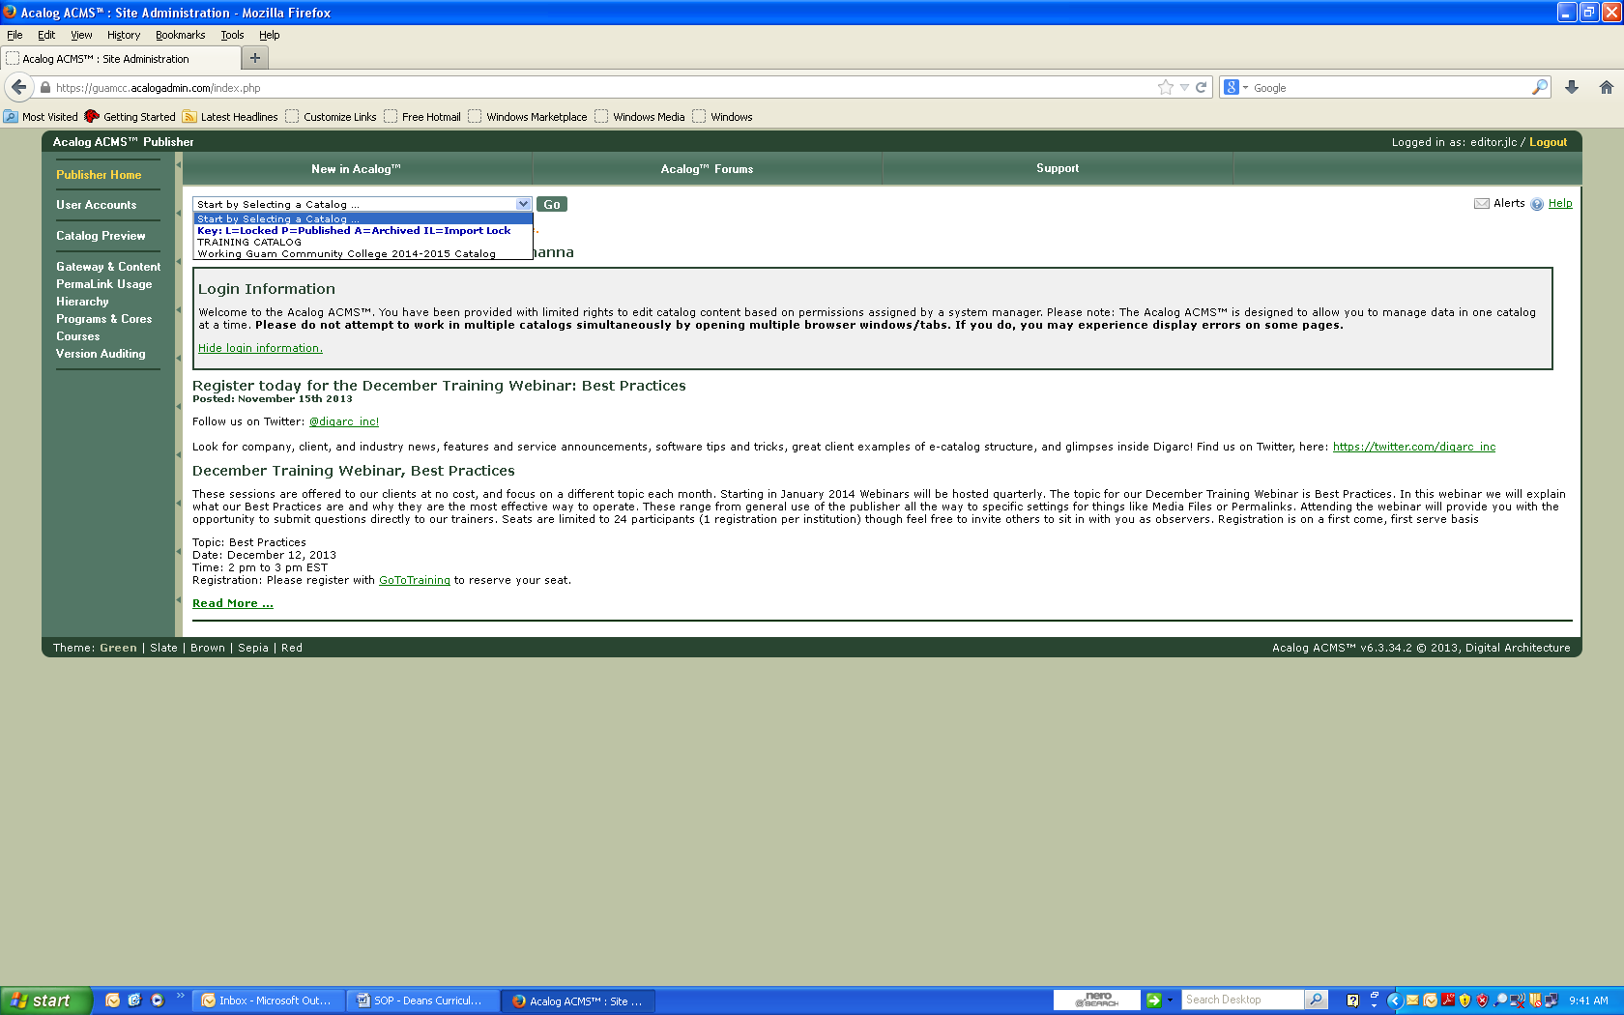

Figure 2

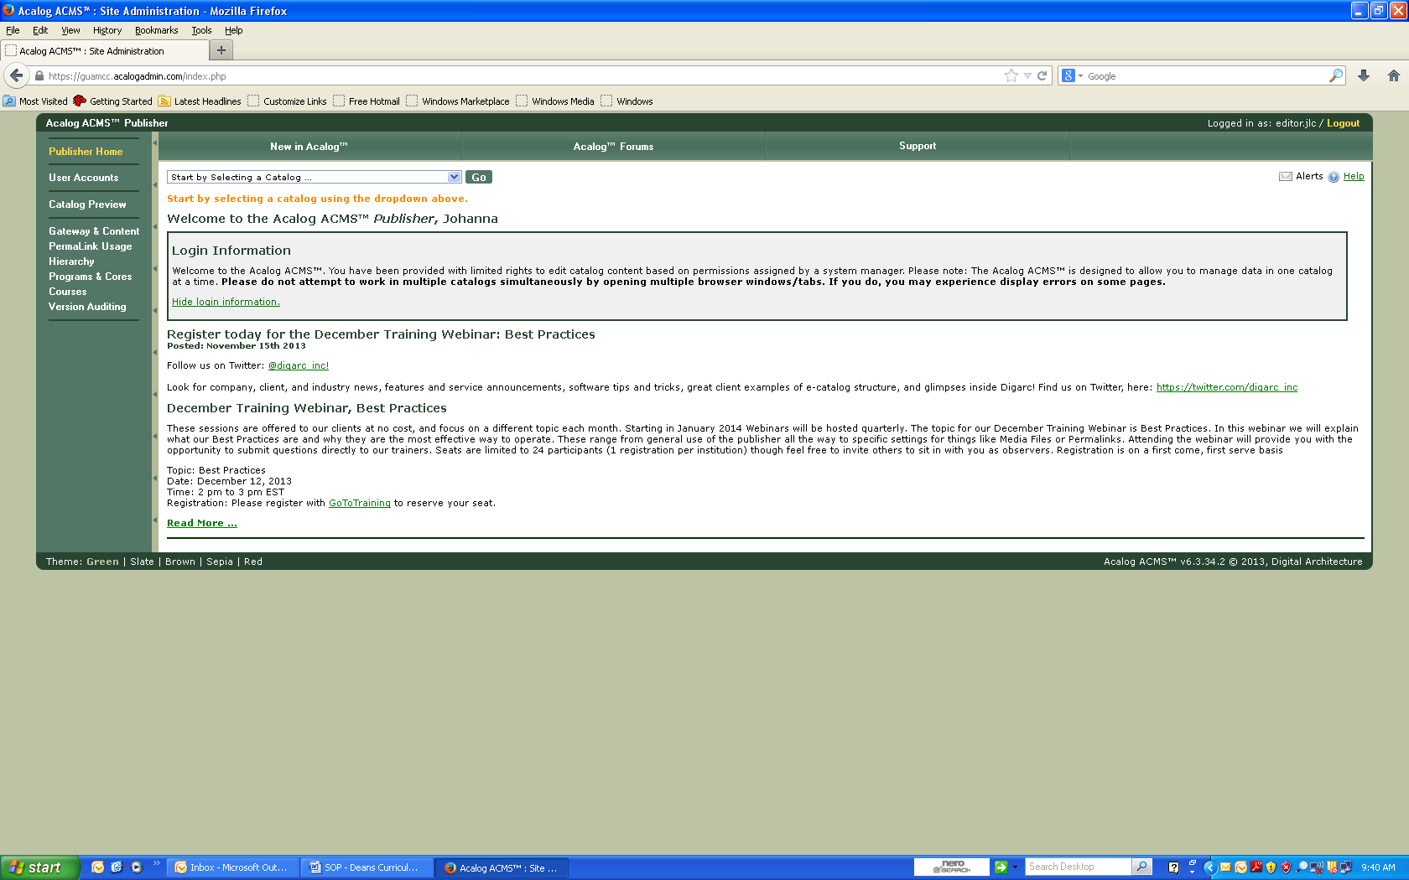

Figure 3

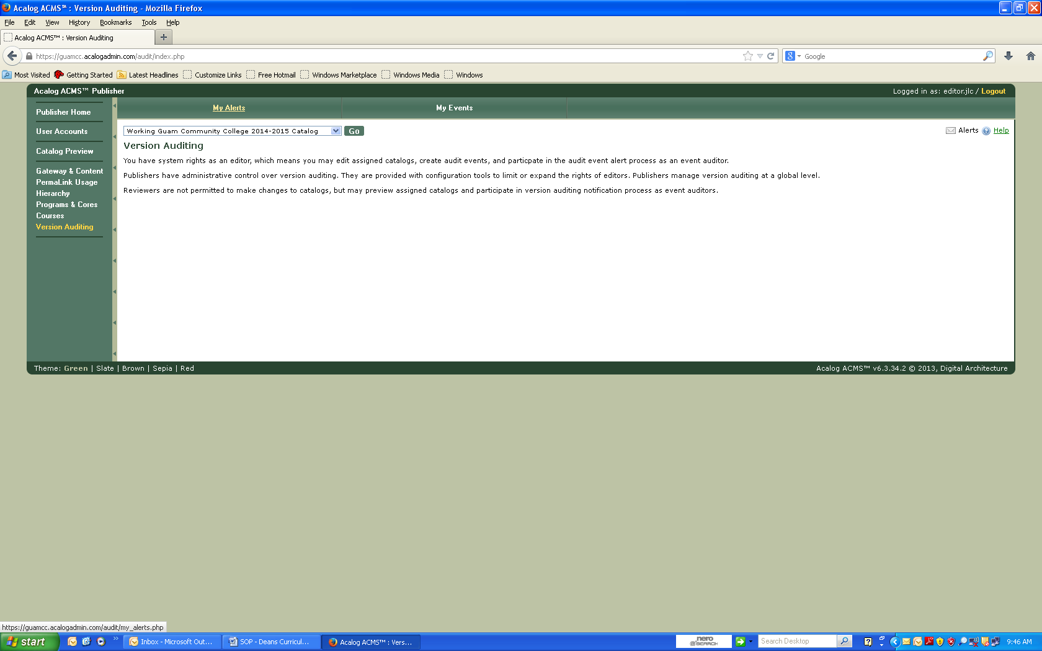

Figure 4

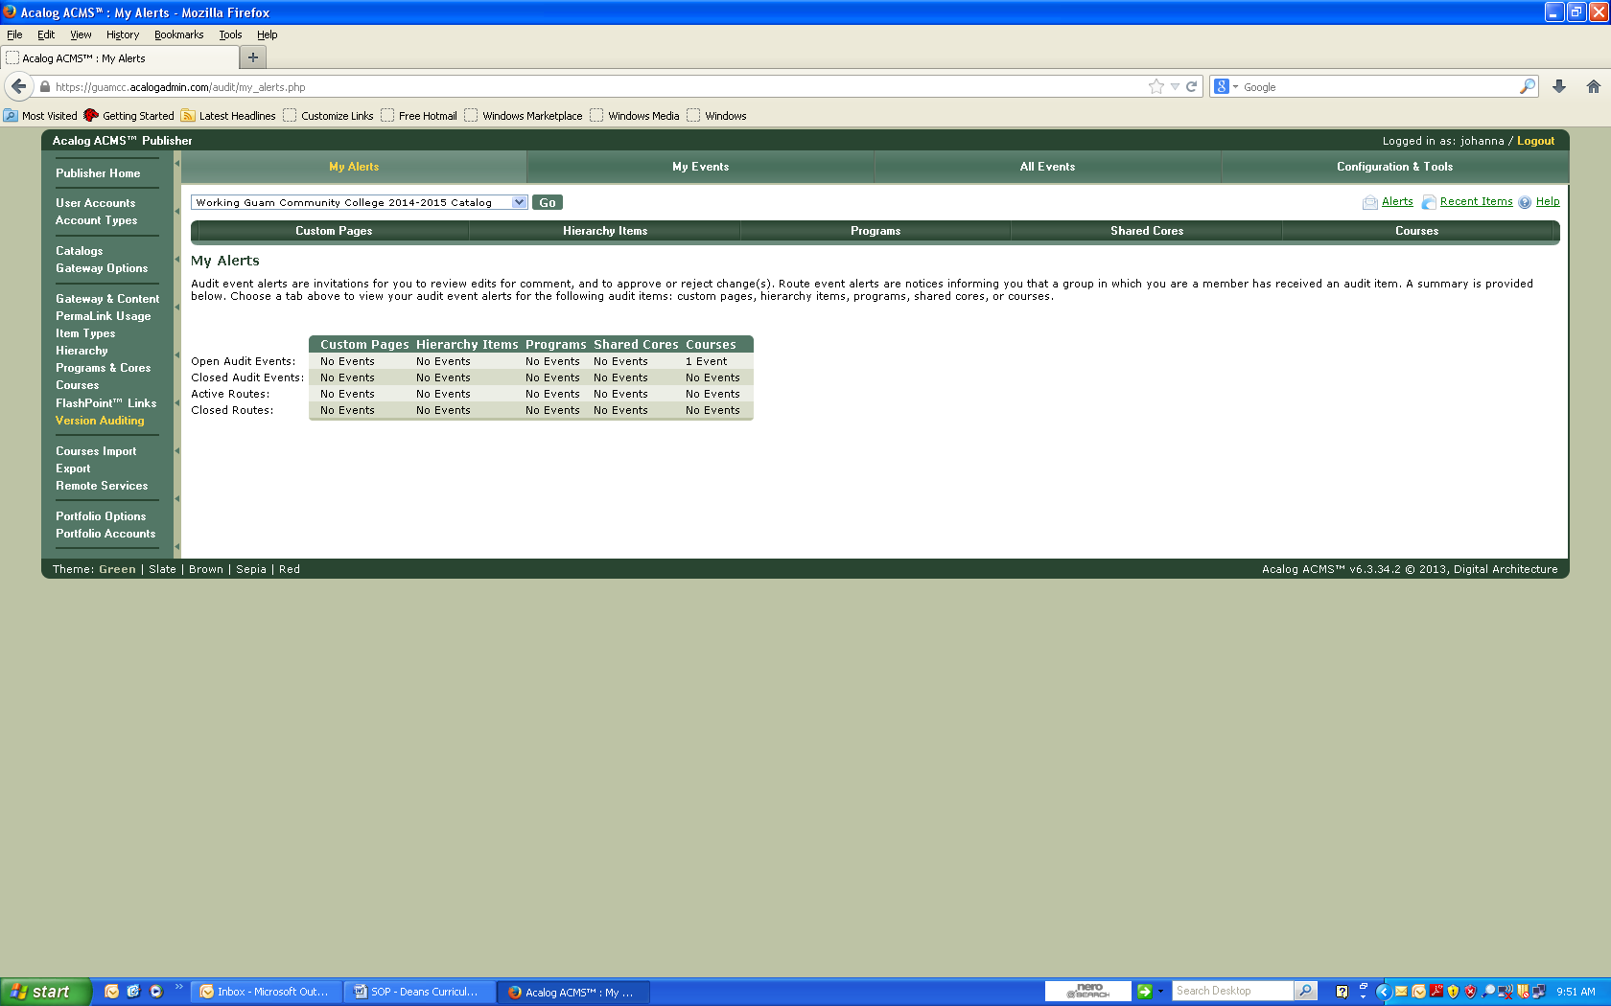

Figure 5

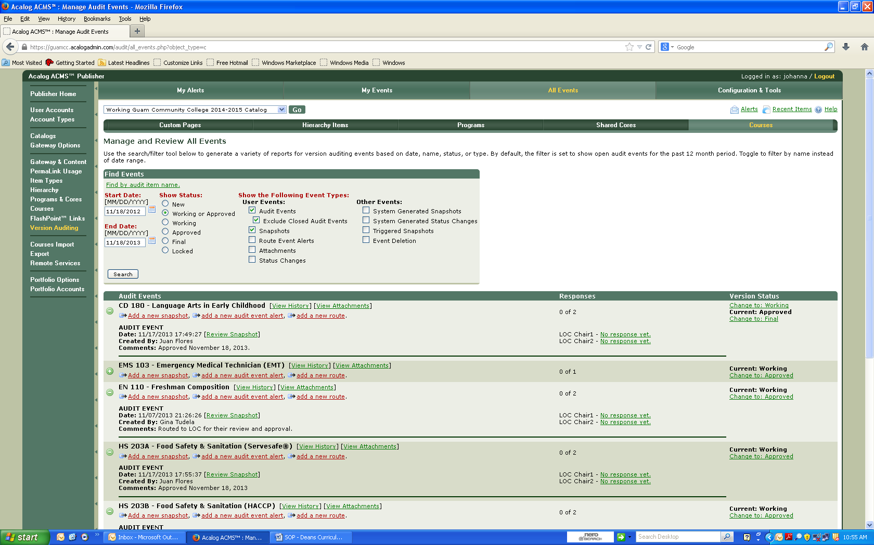

Figure 6

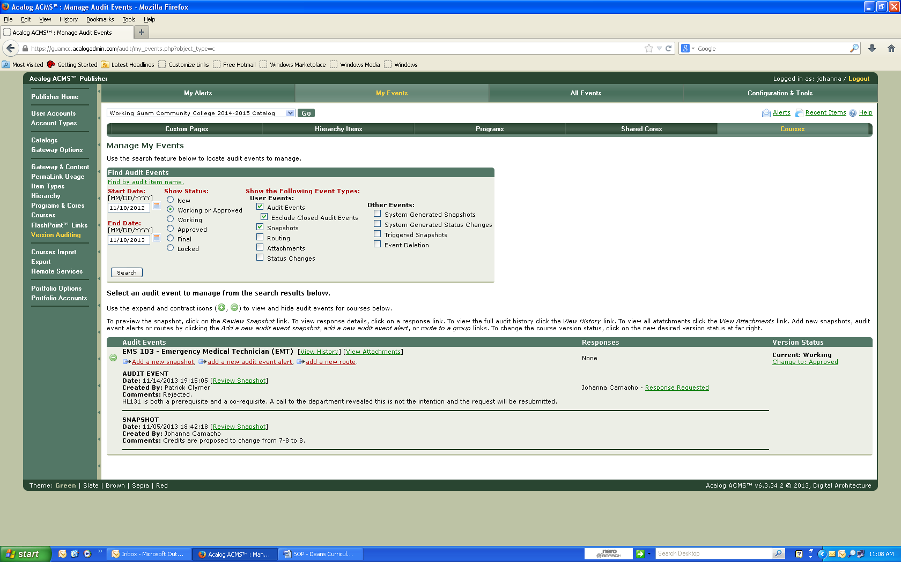



Figure 7

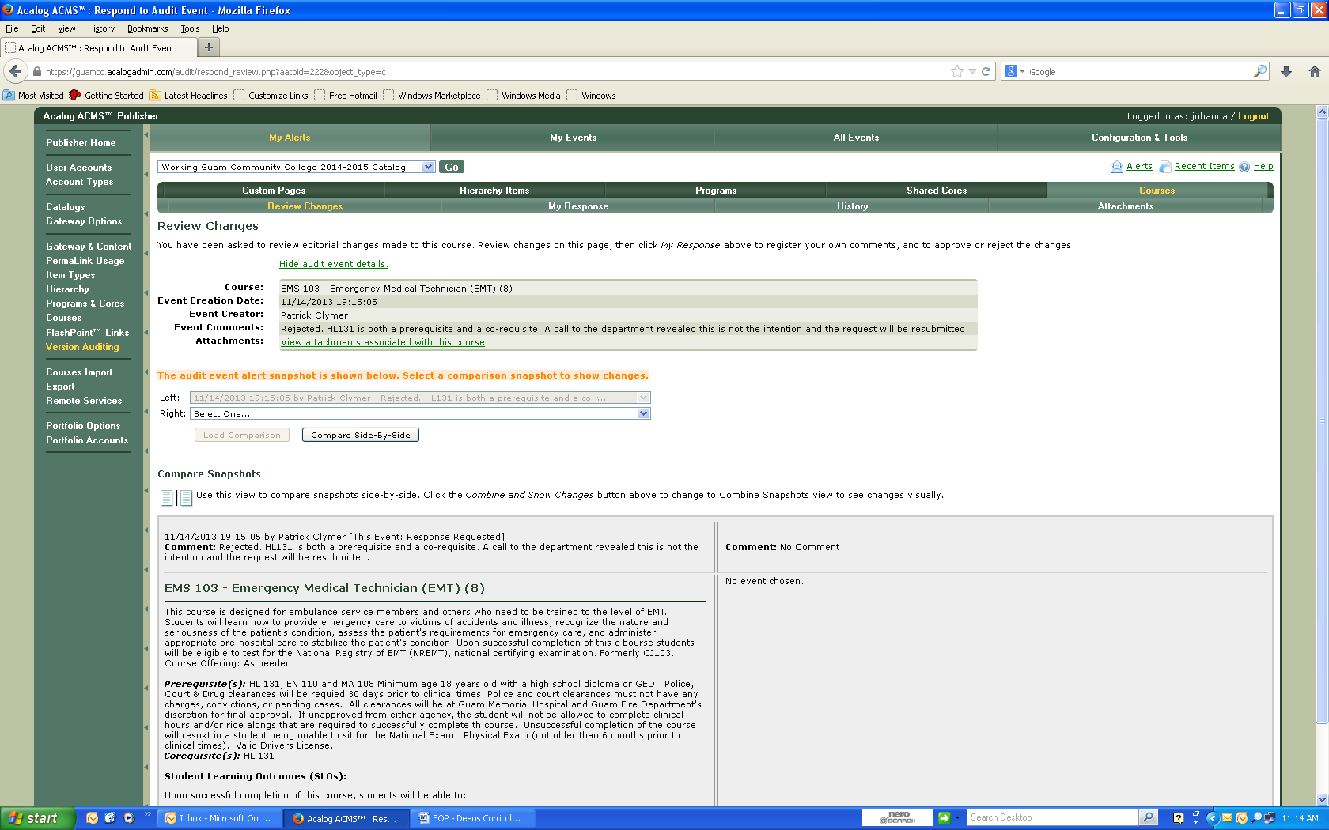

Figure 8

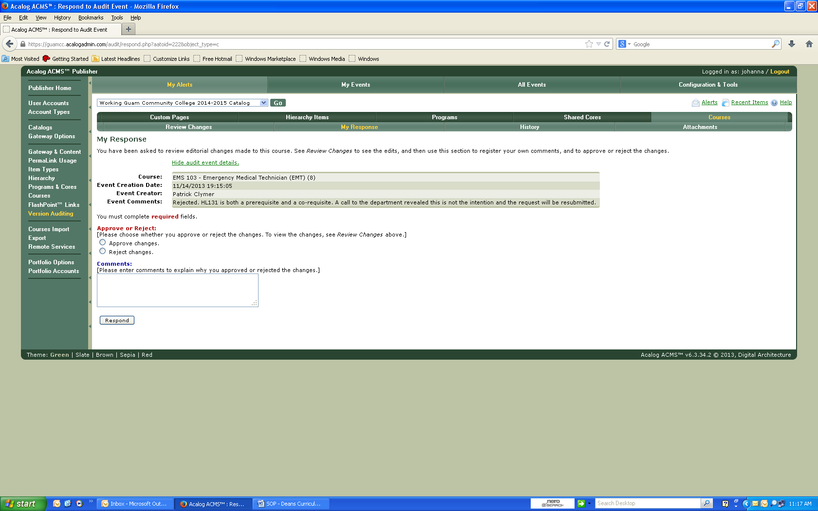

Figure 9

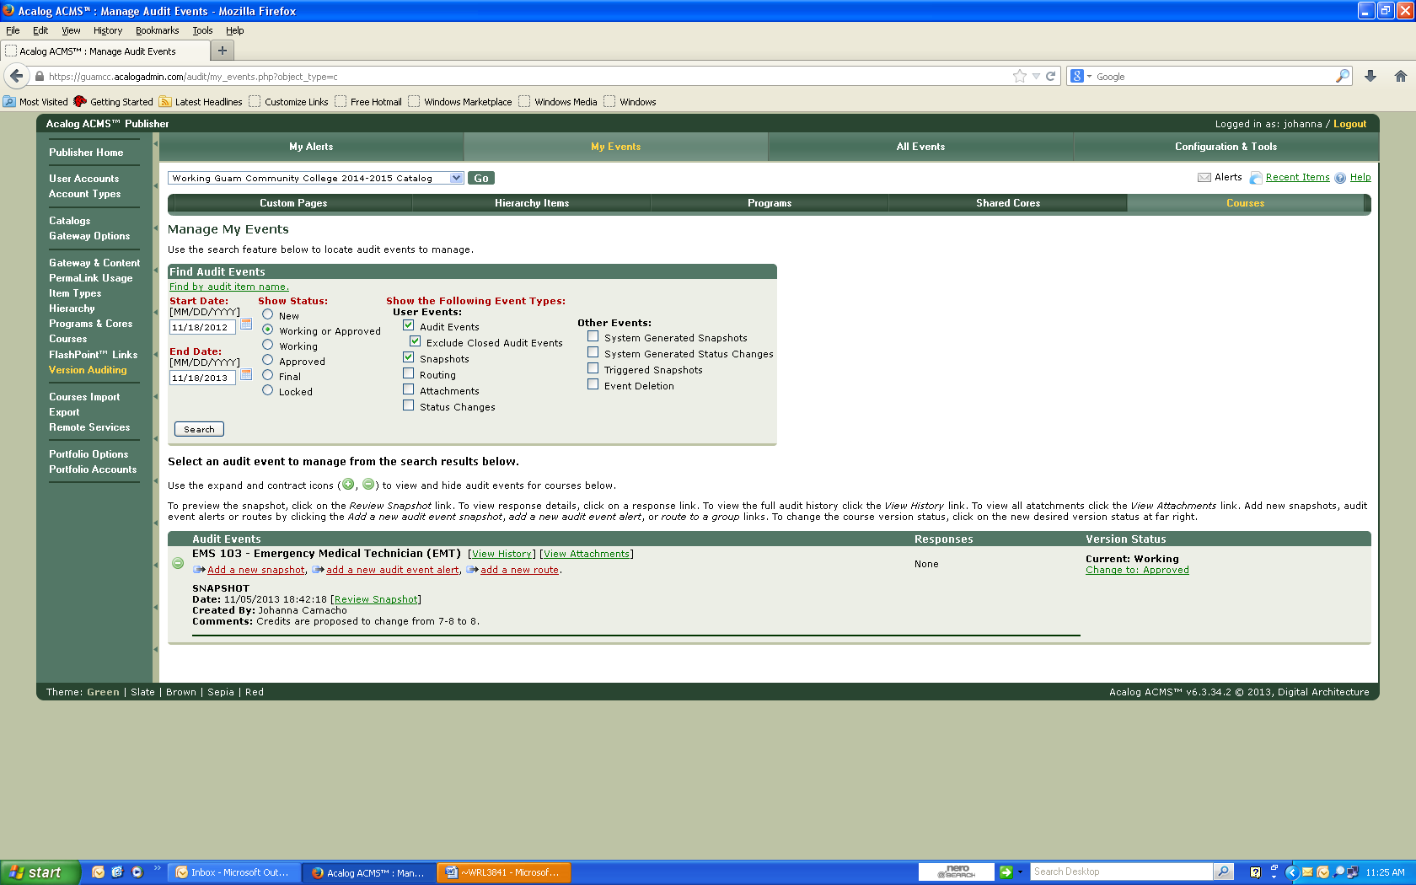



Figure 10

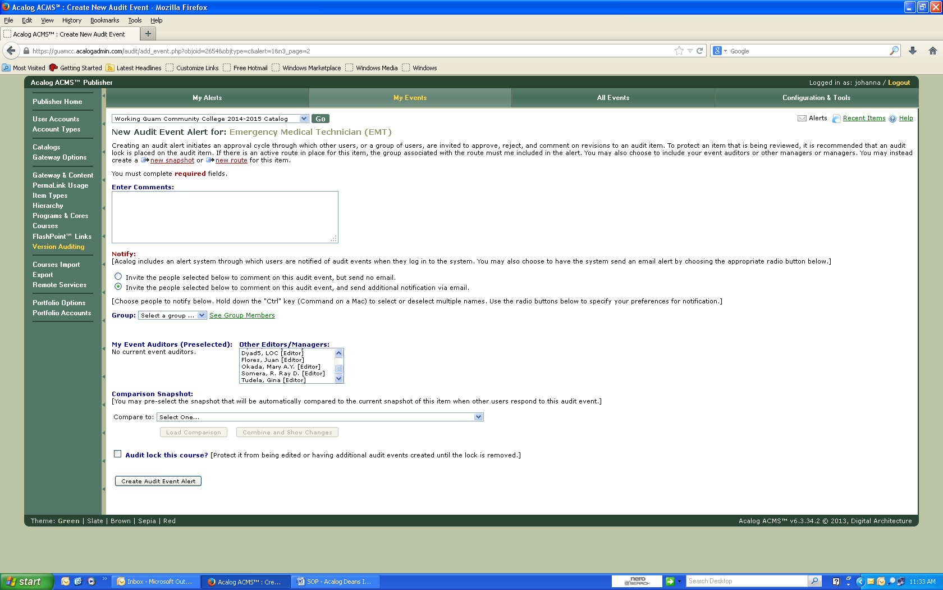

=-=-=-=-=-=-=-=-=-=-=-=-=-=-=-=-=-=-=-=-=-=-=-=-=-=-=-=-=-=-=-=-=-=-=-=-=-=-=-=-=-=-=-=-=-=-=-=-=-=-=-=-=

Document History

First Draft November 20, 2013

Second Draft December 2, 2013

Sent to Deans & AVP December 2, 2013